

**Discipline**

**Elastic File System**

**CS5002**

Activity-20

**Sheikh Muhammed Tadeeb (AU19B1014)**

* **Problem Statement:**

Create an EFS file system and mount it to 2 Ec2 machines. Use the 2nd method shown in the class today. Copy file from one machine to another machine and check whether the EFS worked or not.

* **Theory:**
* **Brief:**

Amazon Elastic File System (Amazon EFS) provides a simple, serverless, set-and-forget elastic file system for use with AWS Cloud services and on-premises resources. It is built to scale on demand to petabytes without disrupting applications, growing and shrinking automatically as you add and remove files, eliminating the need to provision and manage capacity to accommodate growth. Amazon EFS has a simple web services interface that allows us to create and configure file systems quickly and easily. The service manages all the file storage infrastructure for us, meaning that we can avoid the complexity of deploying, patching, and maintaining complex file system configurations.

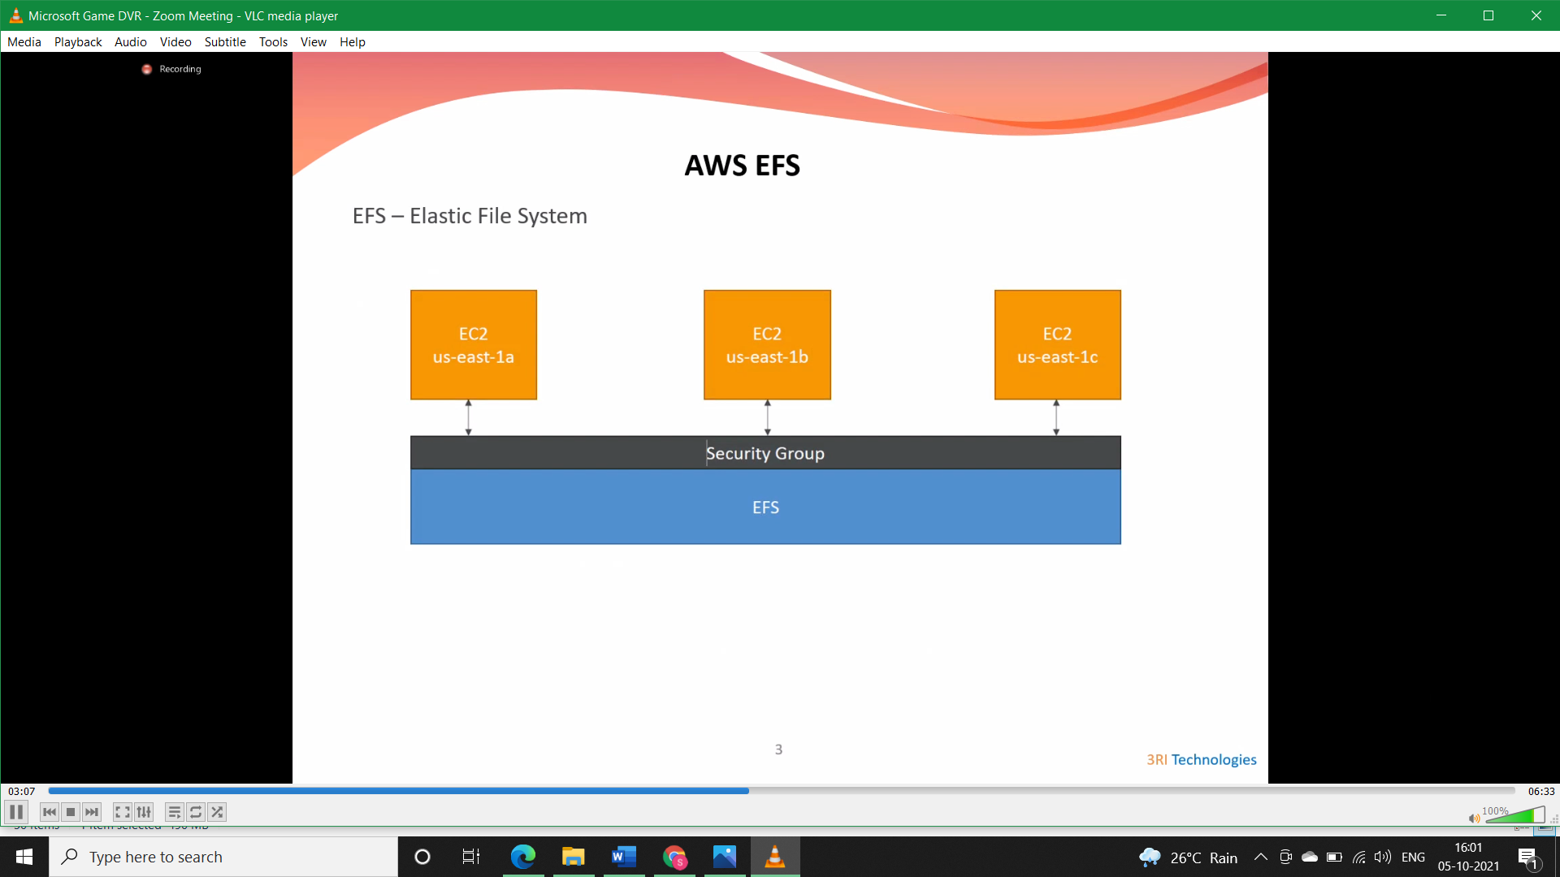

* **Protocol used by EFS:**

Amazon EFS supports the Network File System version 4 (NFSv4.1 and NFSv4.0) protocol, so the applications and tools that you use today work seamlessly with Amazon EFS. Multiple compute instances, including Amazon EC2, Amazon ECS, and AWS Lambda, can access an Amazon EFS file system at the same time, providing a common data source for workloads and applications running on more than one compute instance or server.

* **Storage Classes used by EFS:**

With Amazon EFS, we pay only for the storage used by our file system and there is no minimum fee or setup cost. Amazon EFS offers a range of storage classes designed for different use cases. These include:

* **Standard storage classes** – EFS Standard and EFS Standard–Infrequent Access (Standard–IA), which offer multi-AZ resilience and the highest levels of durability and availability.
* **One Zone storage classes** – EFS One Zone and EFS One Zone–Infrequent Access (EFS One Zone–IA), which offer customers the choice of additional savings by choosing to save their data in a single AZ’.
* **Security aspects of EFS:**
  1. Amazon EFS also enables you to control access to your file systems through Portable Operating System Interface (POSIX) permissions.
  2. Amazon EFS supports authentication, authorization, and encryption capabilities to help you meet our security and compliance requirements.
  3. Amazon EFS supports two forms of encryption for file systems, encryption in transit and encryption at rest.
* We can enable encryption at rest when creating an Amazon EFS file system. If we do this, all your data and metadata is encrypted.
* We can also enable encryption in transit when we mount the file system.
* **Modes of EFS:**

With Amazon EFS, you can choose from two performance modes and two throughput modes:

* The default General Purpose performance mode is ideal for latency-sensitive use cases, like web serving environments, content management systems, home directories, and general file serving. File systems in the Max I/O mode can scale to higher levels of aggregate throughput and operations per second with a trade-off of slightly higher latencies for file metadata operations.
* Using the default Bursting Throughput mode, throughput scales as your file system grows. Using Provisioned Throughput mode, you can specify the throughput of your file system independent of the amount of data stored.
* **Difference between EFS & EBS & S3 & FSx:**

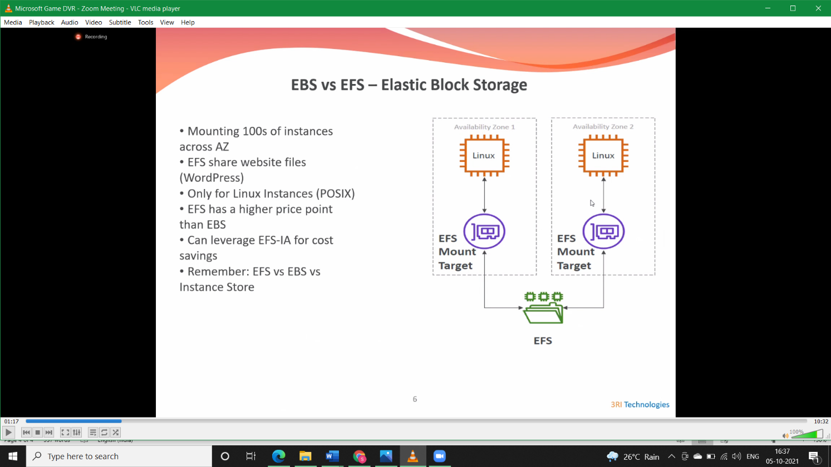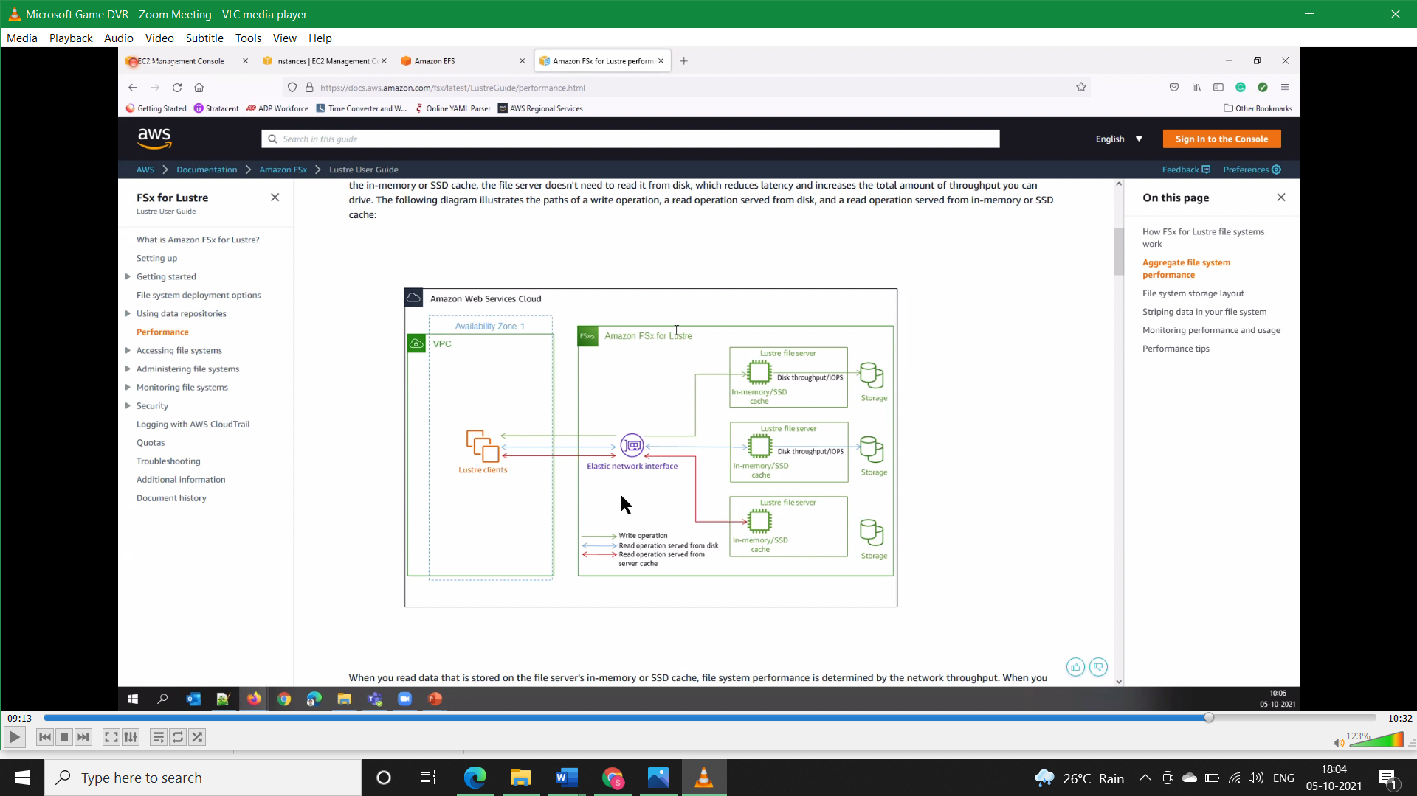

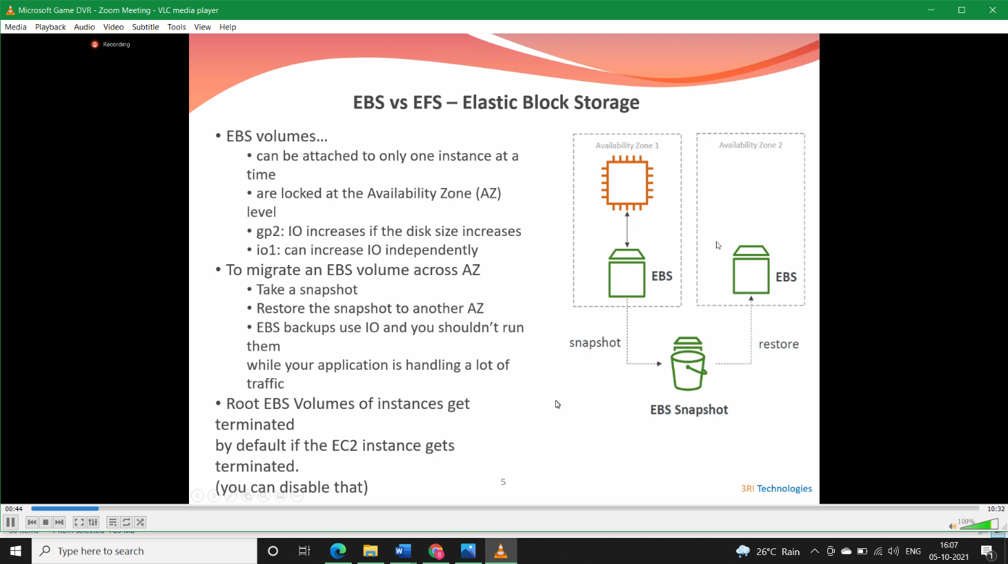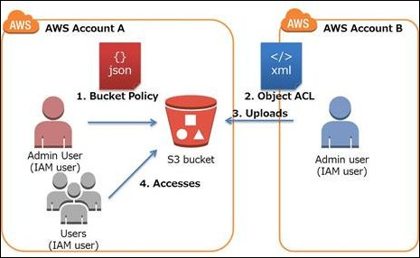

* EBS’s use case is more easily understood than the other two. It must be paired with an EC2 instance. So, when you need a high-performance storage service for a single instance, use EBS.
* EFS may be used whenever you need a shared file storage option for multiple EC2 instances with automatic, high-performance scaling. This makes it a great candidate for file storage for content management systems, for lift and shift operations, as its autoscaling potential means you do not need to re-architect; for application development, as EFS’s shareable file storage is ideal for storing code and media files.
* S3 is an object storage system, designed to provide archiving and data control options and to interface with other services beyond EC2. It’s also useful for storing static html pages and shared storage for applications.
* As FSx uses Windows, it's compatible with all Window Server platforms. On the other hand, EFS uses NFS protocol which works on POSIX permissions and hence EFS is only supported by Linux machine. You get to choose from two services:
  1. Amazon FSx for Windows File Server - file storage for business apps.
  2. Amazon FSx for Lustre - shared storage for computing workloads.
* **Solution:**
* **Step1)** Create two instances (ex: VM1-AZ-1A & VM2-AZ-1B), make sure the two instances are in different subnets and both are Linux based as NFS is only supported on Linux Machines.

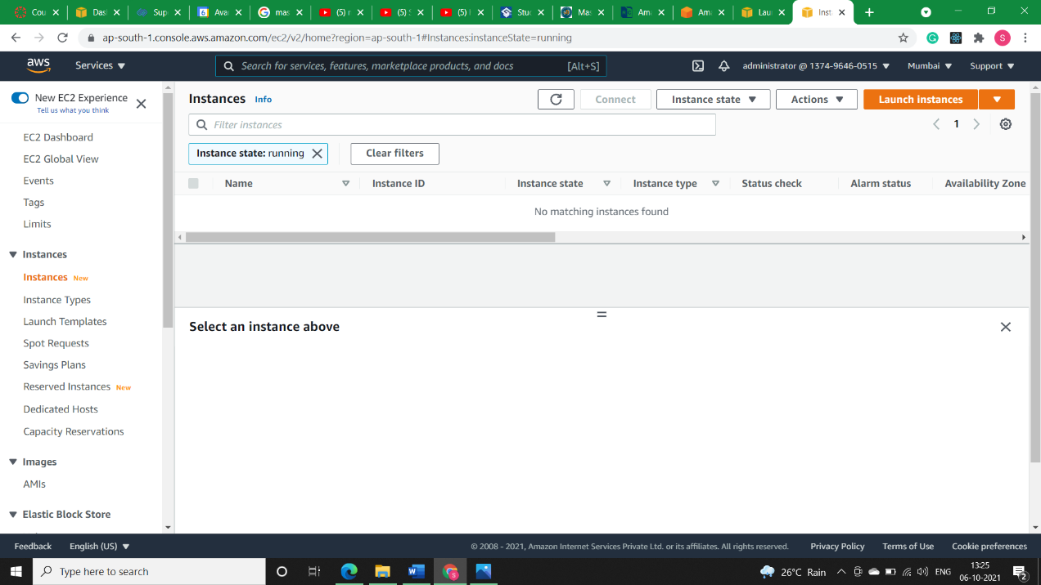

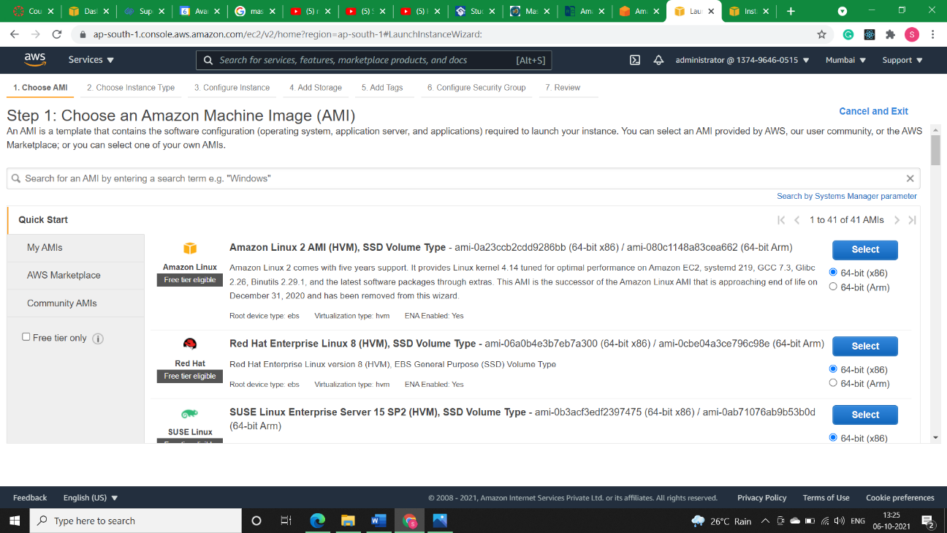

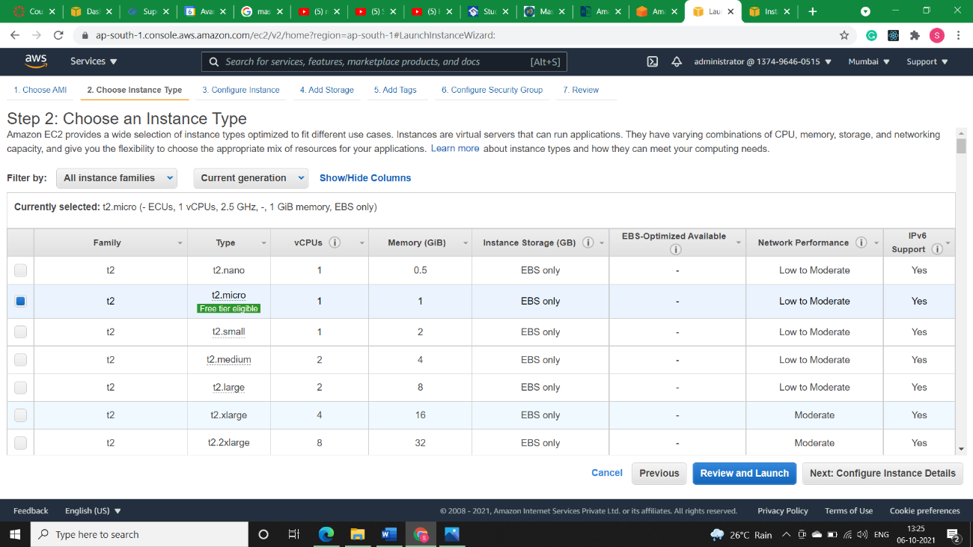

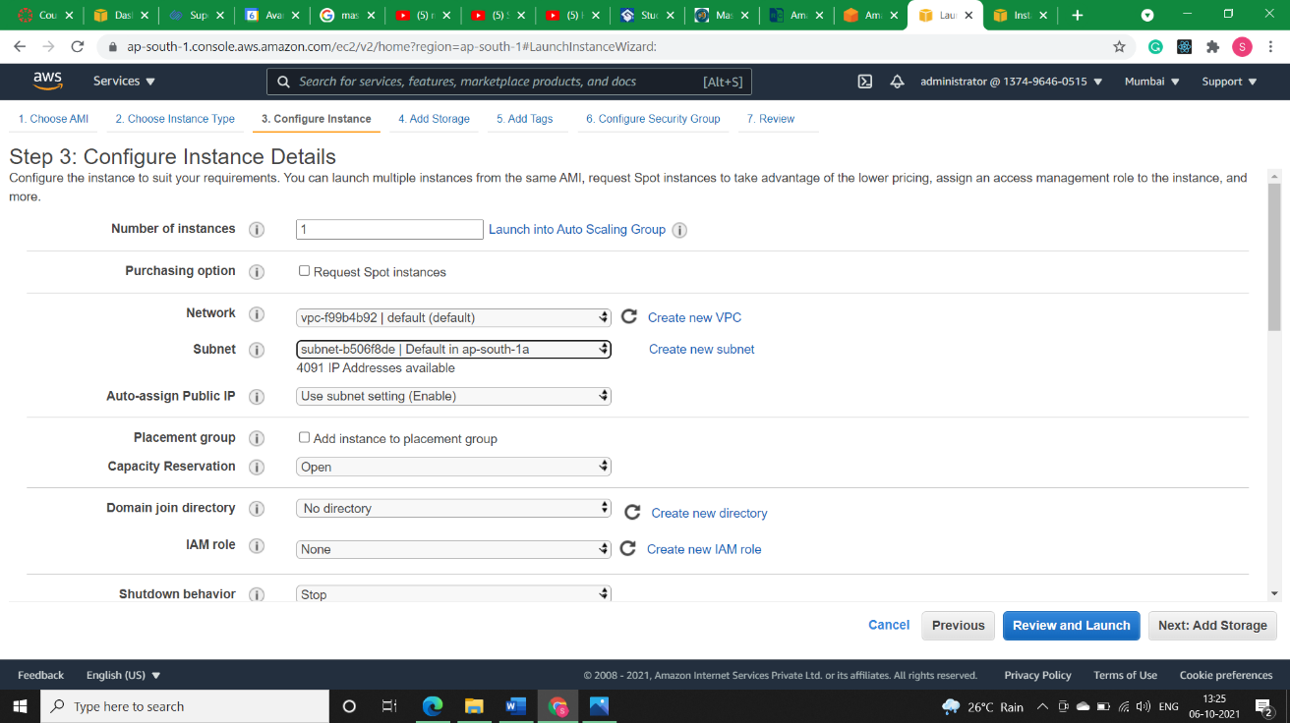

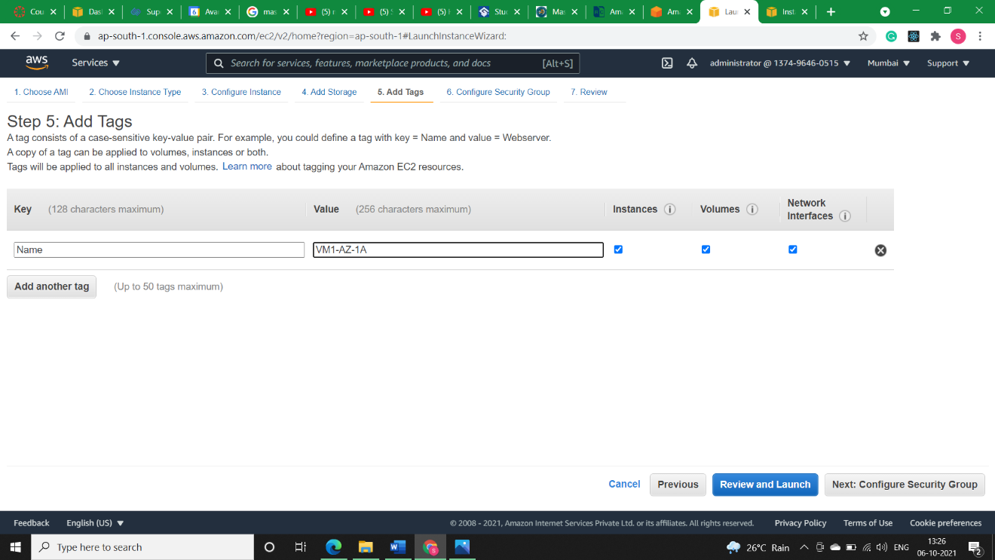

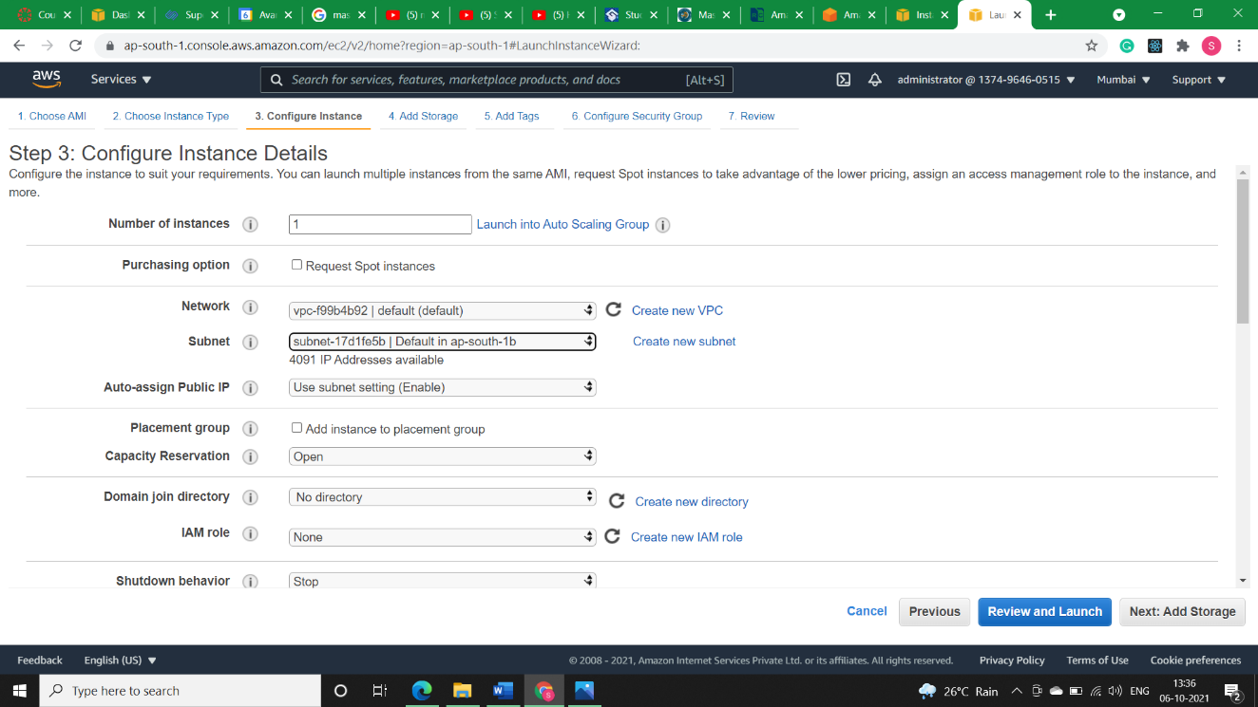

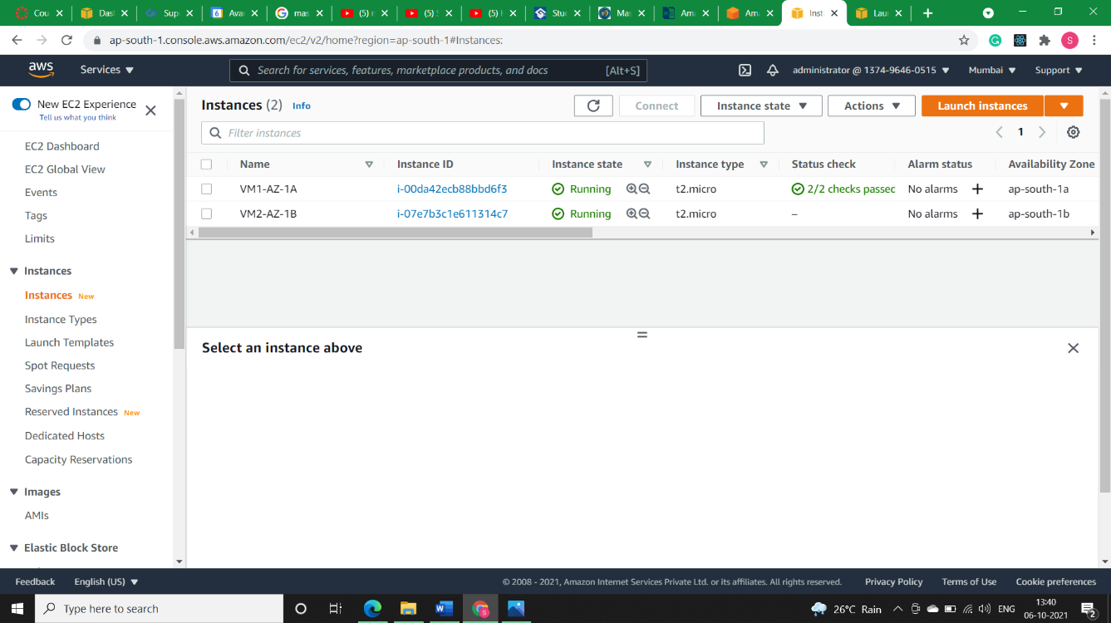

* 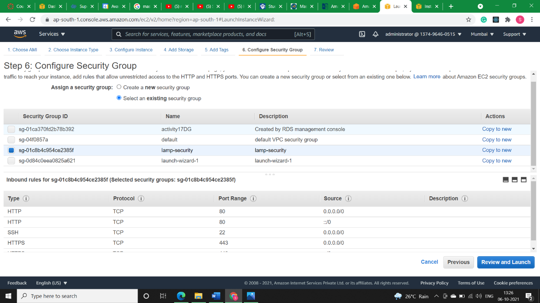**Step2)** Add Security group having ports 22 i.e., SSH, port 80 i.e., HTTP and port 443 i.e., HTPS enabled to both the machines.
* 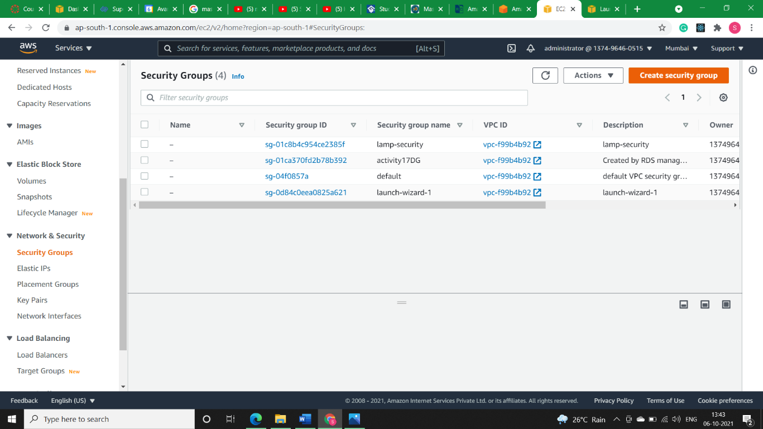**Step3)** Create a security group for EFS (example: efs-file-access-sg) with inbound rule as NFS and source is security group of ec2-instance.

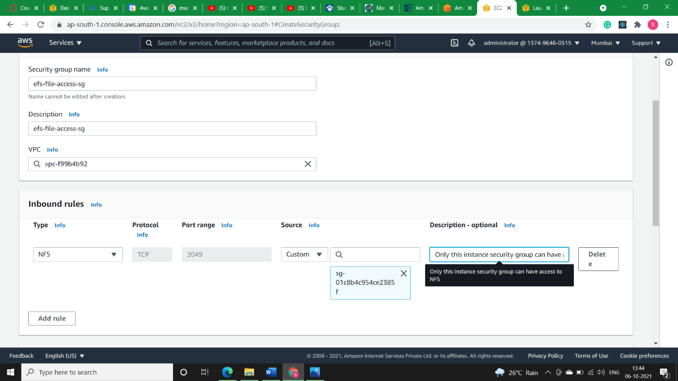

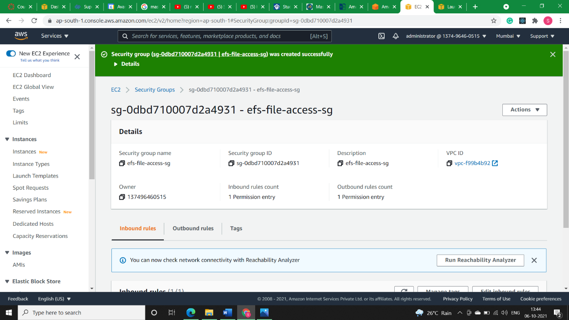

* **Step4)** Create an EFS (example: SharedFile-access) under default VPC and regional AZ.

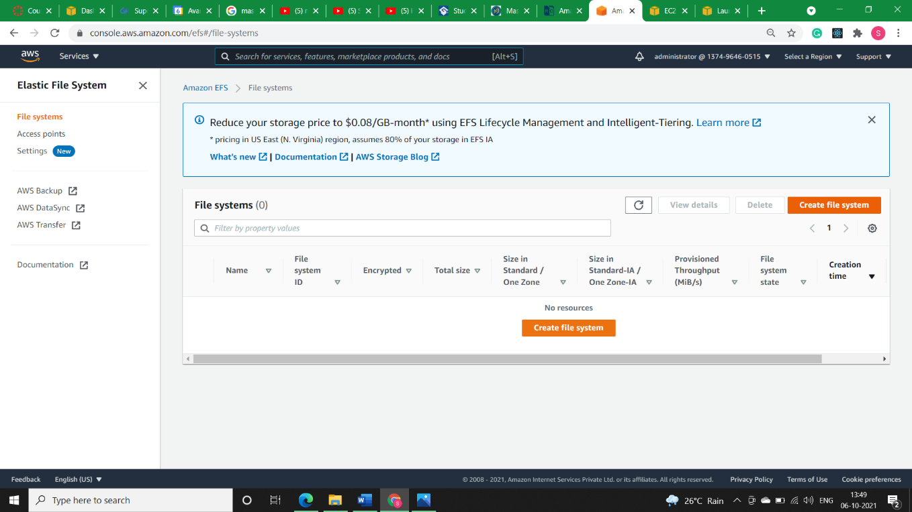

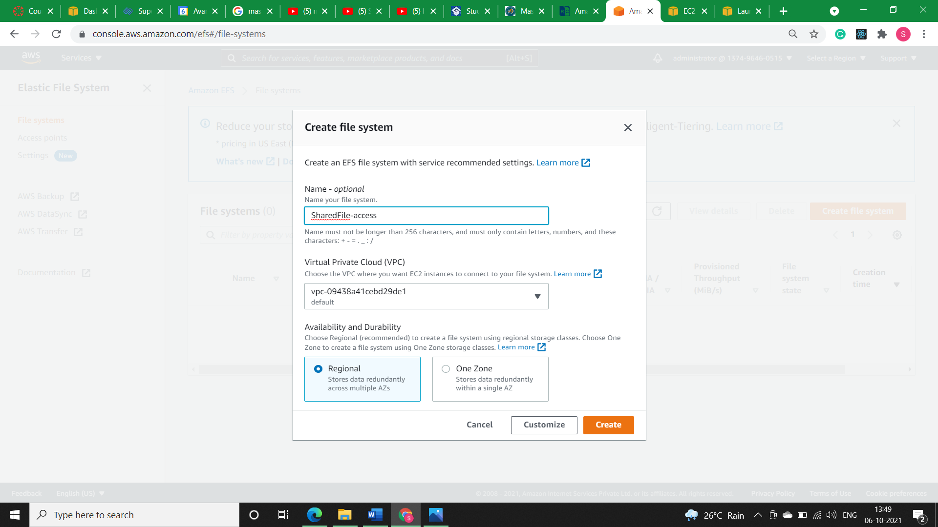

* **Step5)** Click on Customise in above step and *uncheck automatic backups* and *disable encryption* as we are making this EFS for testing purpose but when doing it for enterprises the scenario will be different.The click *Next.*

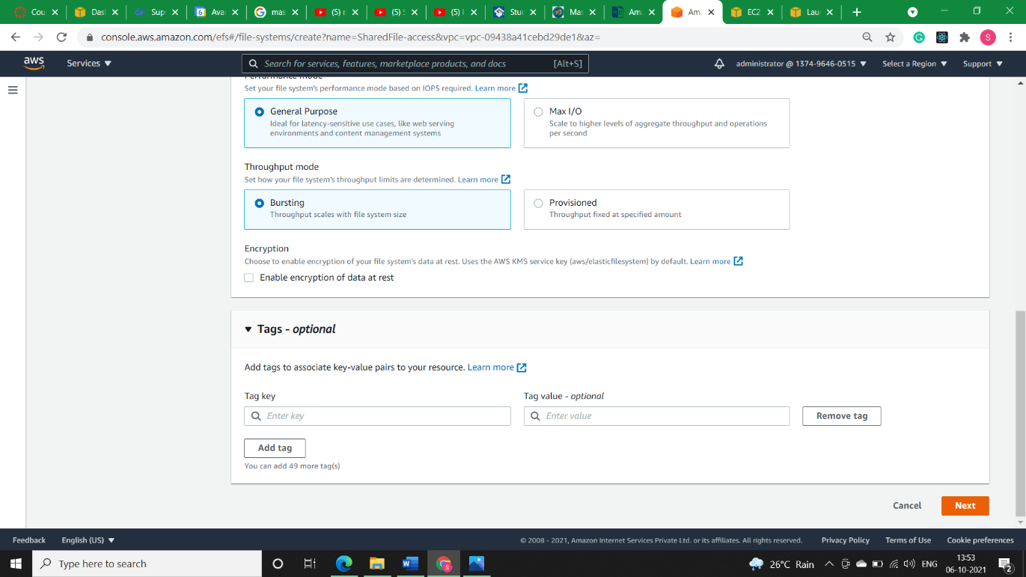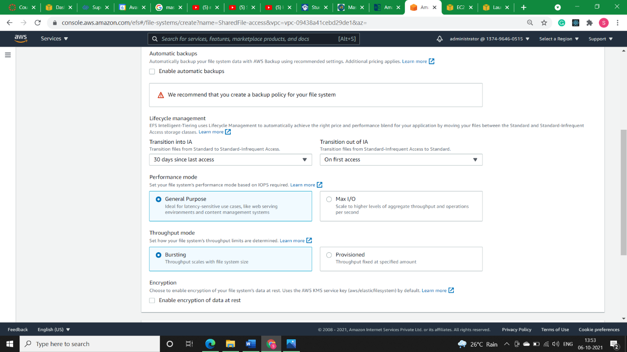

* **Step6)** In Network Access we’ll make our NFS available to different Az’s. Make sure to remove default security group from source and give security group of EFS in source. Click *Next.*

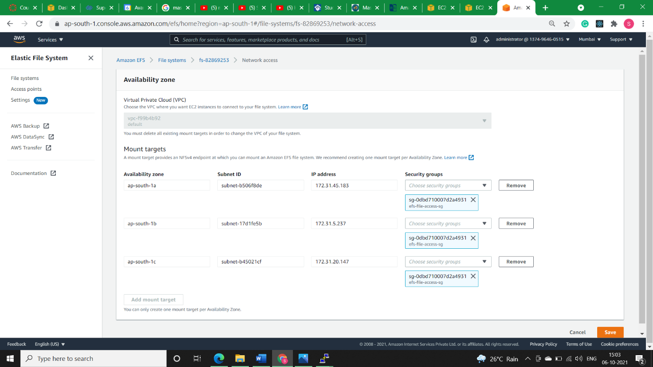

* **Step7)** As this is a test EFS we won’t mention any policies but when working in enterprises it is crucial to set policies.Click *Next.*

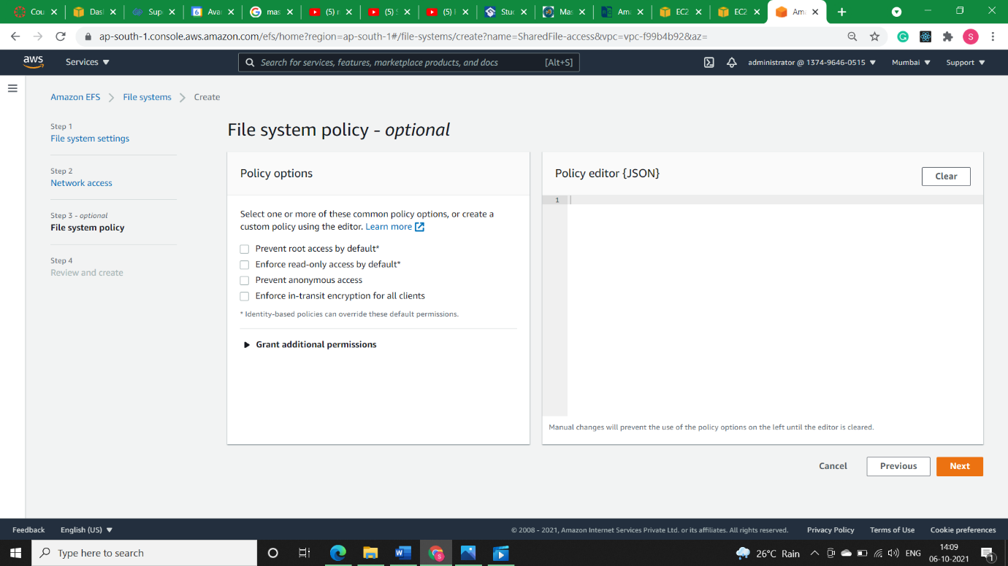

* **Step8)** Open putty and change two machines foreground colour so that we can rectif them easily.
* **Machine 1 (VM1-AZ-1A):**

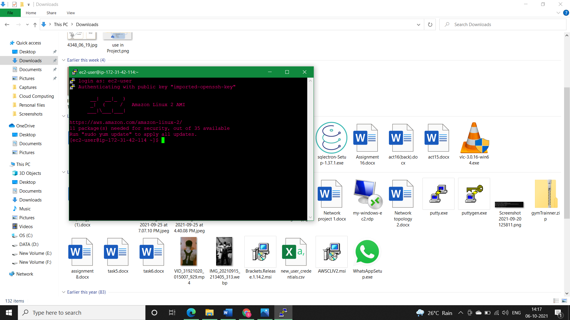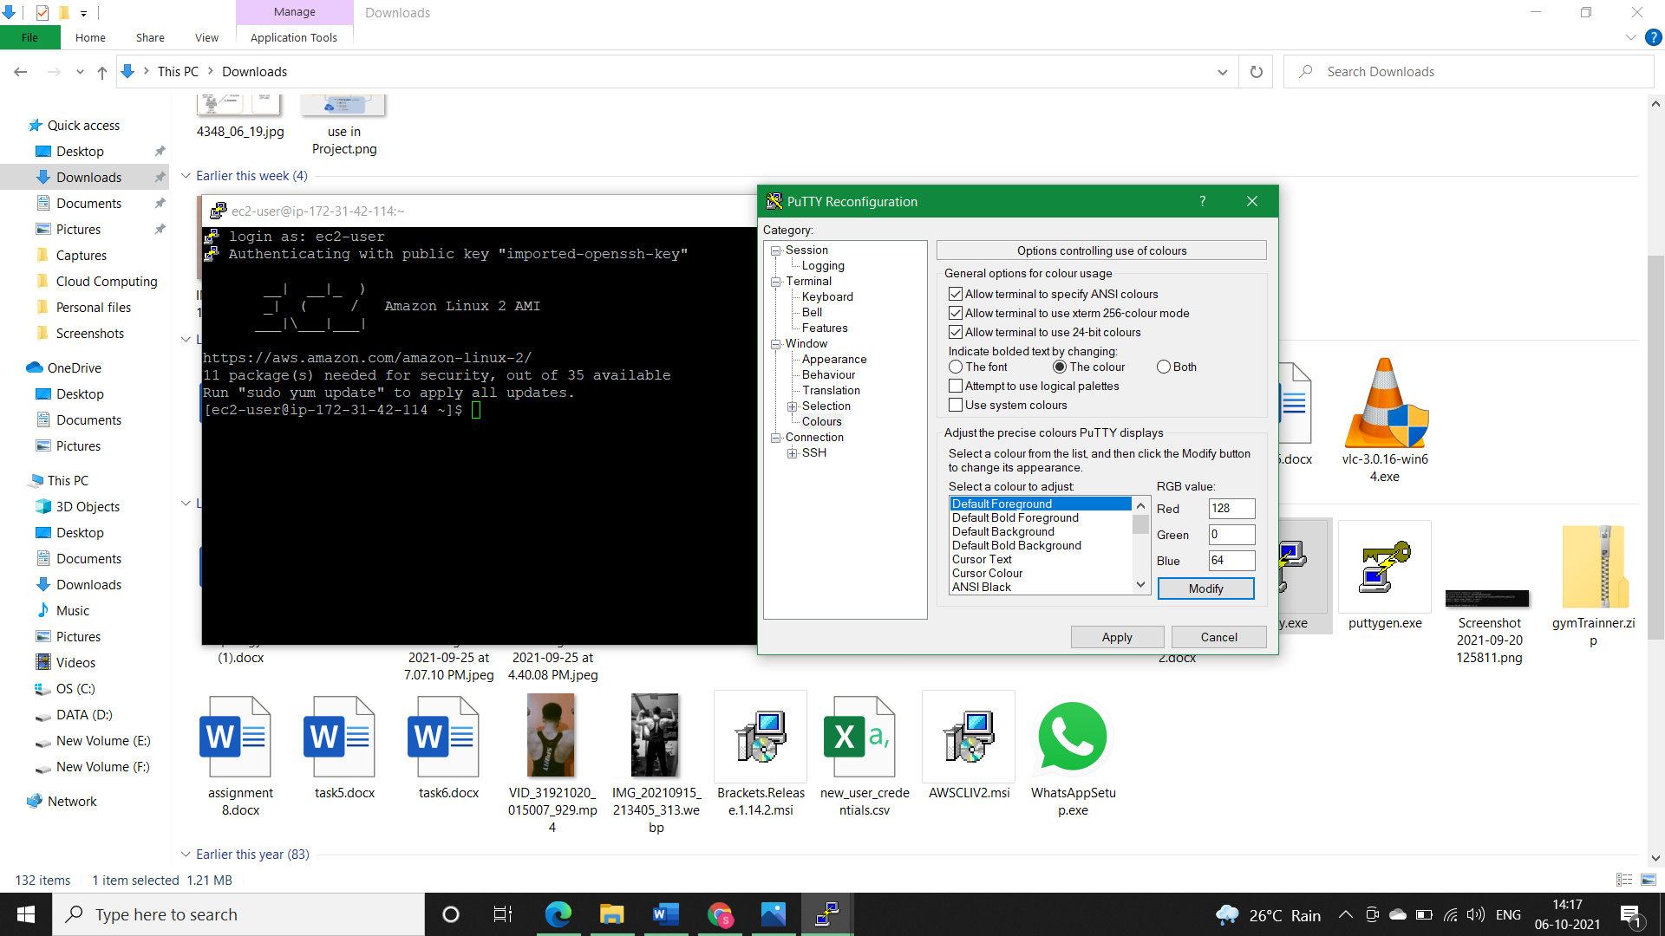

* **Machine 2 (VM2-AZ-1B):**

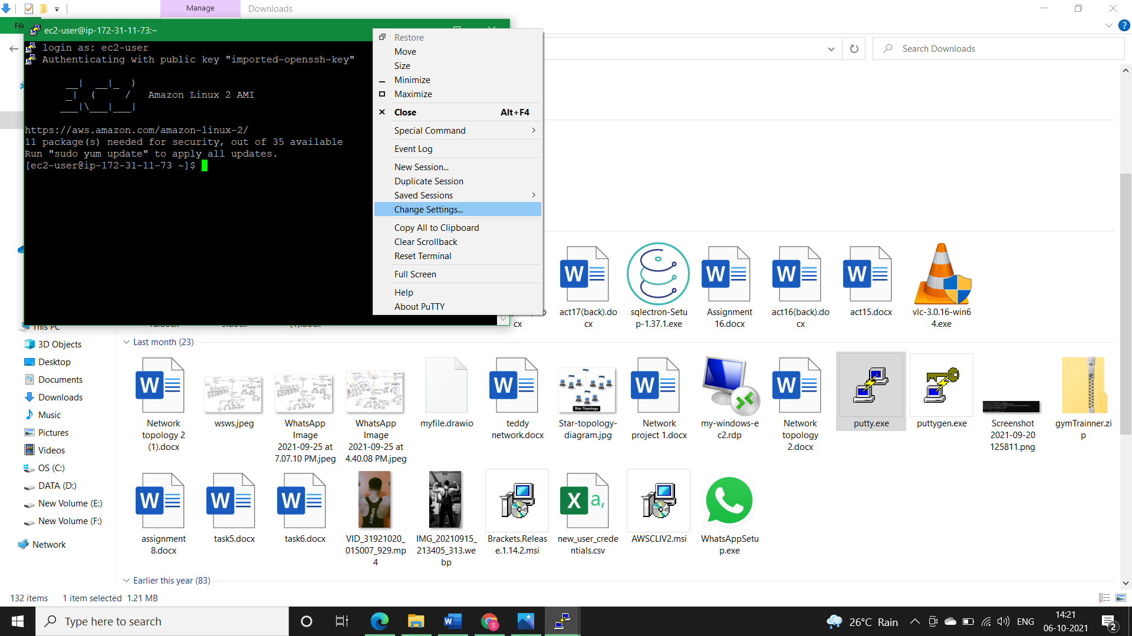

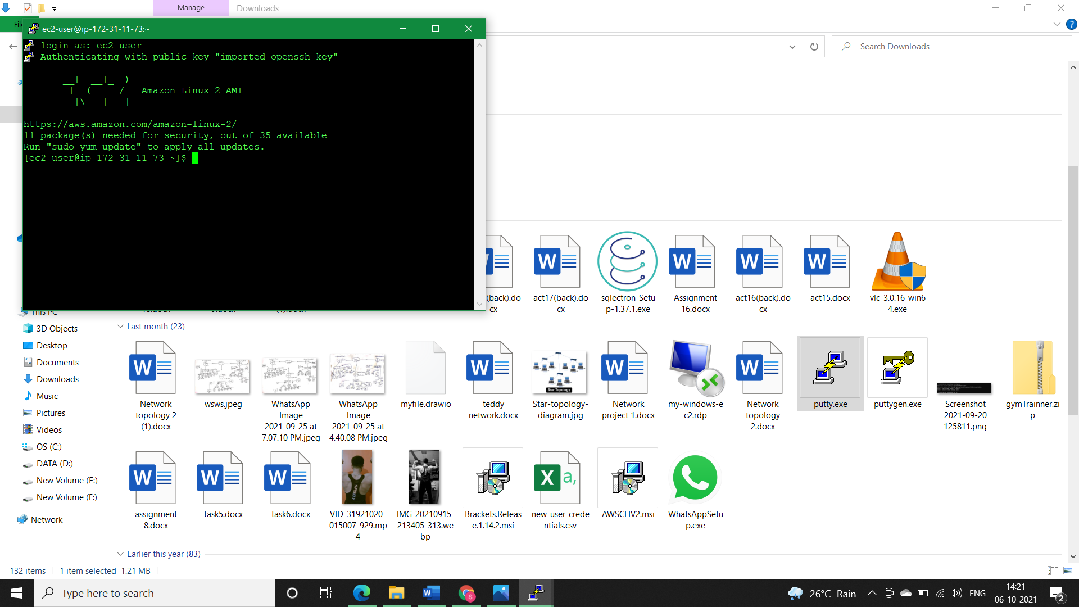

* 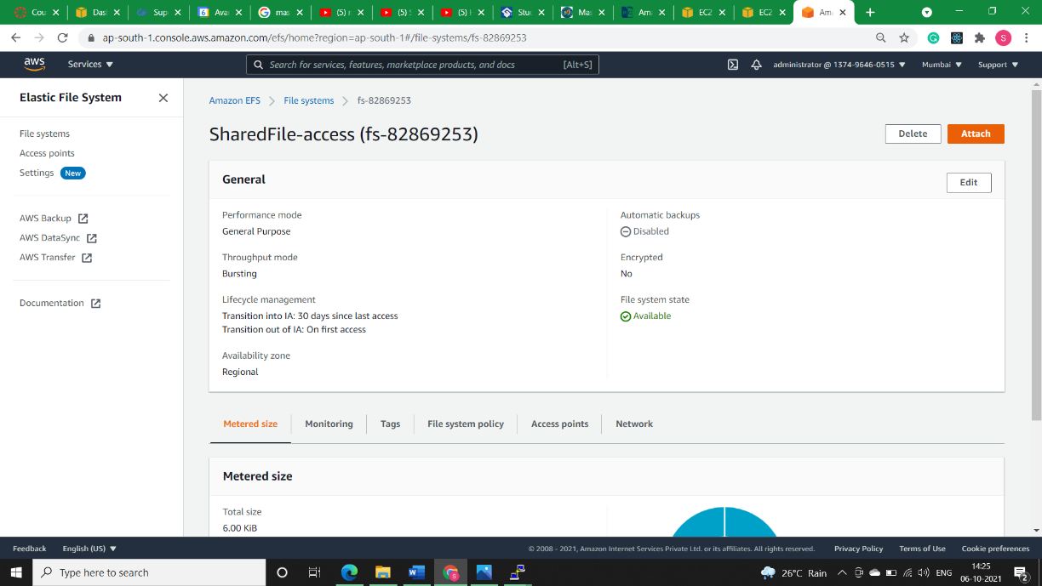**Step9)** Now we need to attach EFS to our both machines, Go to EFS and Click *Attach.*

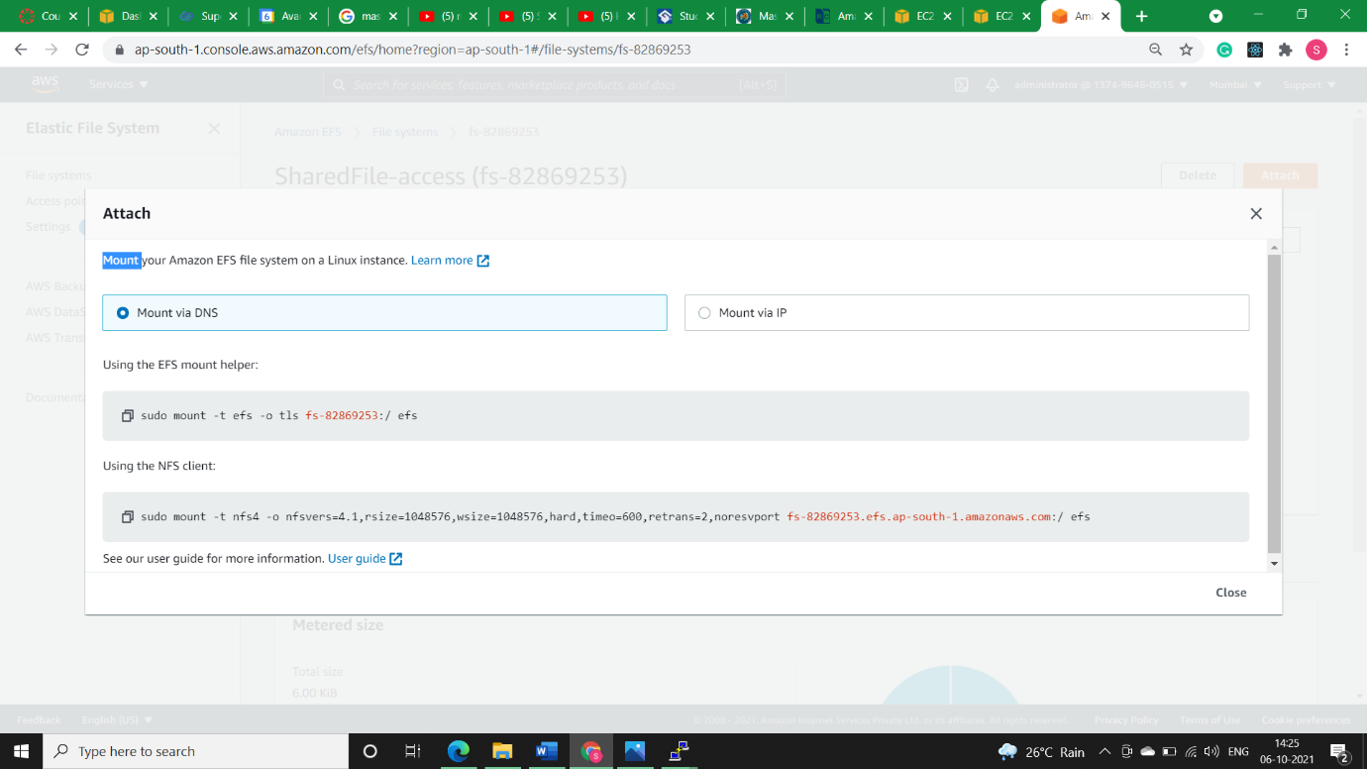

* **Step10)** Install NFS utility in both the machines with the command:

*sudo yum install -y nfs-utils*

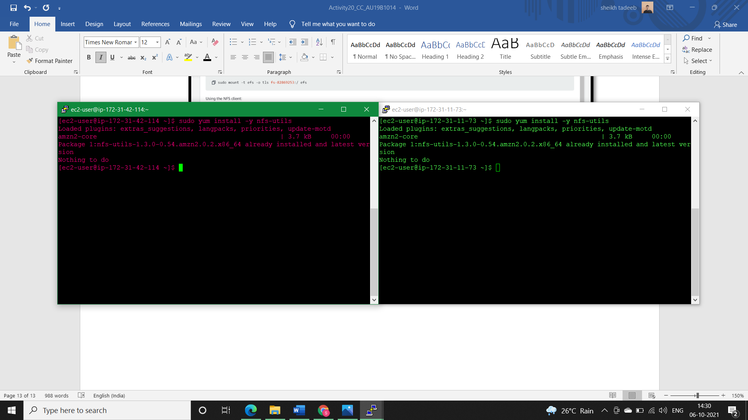

* **Step11)** Create *efs* folder in both the machines.

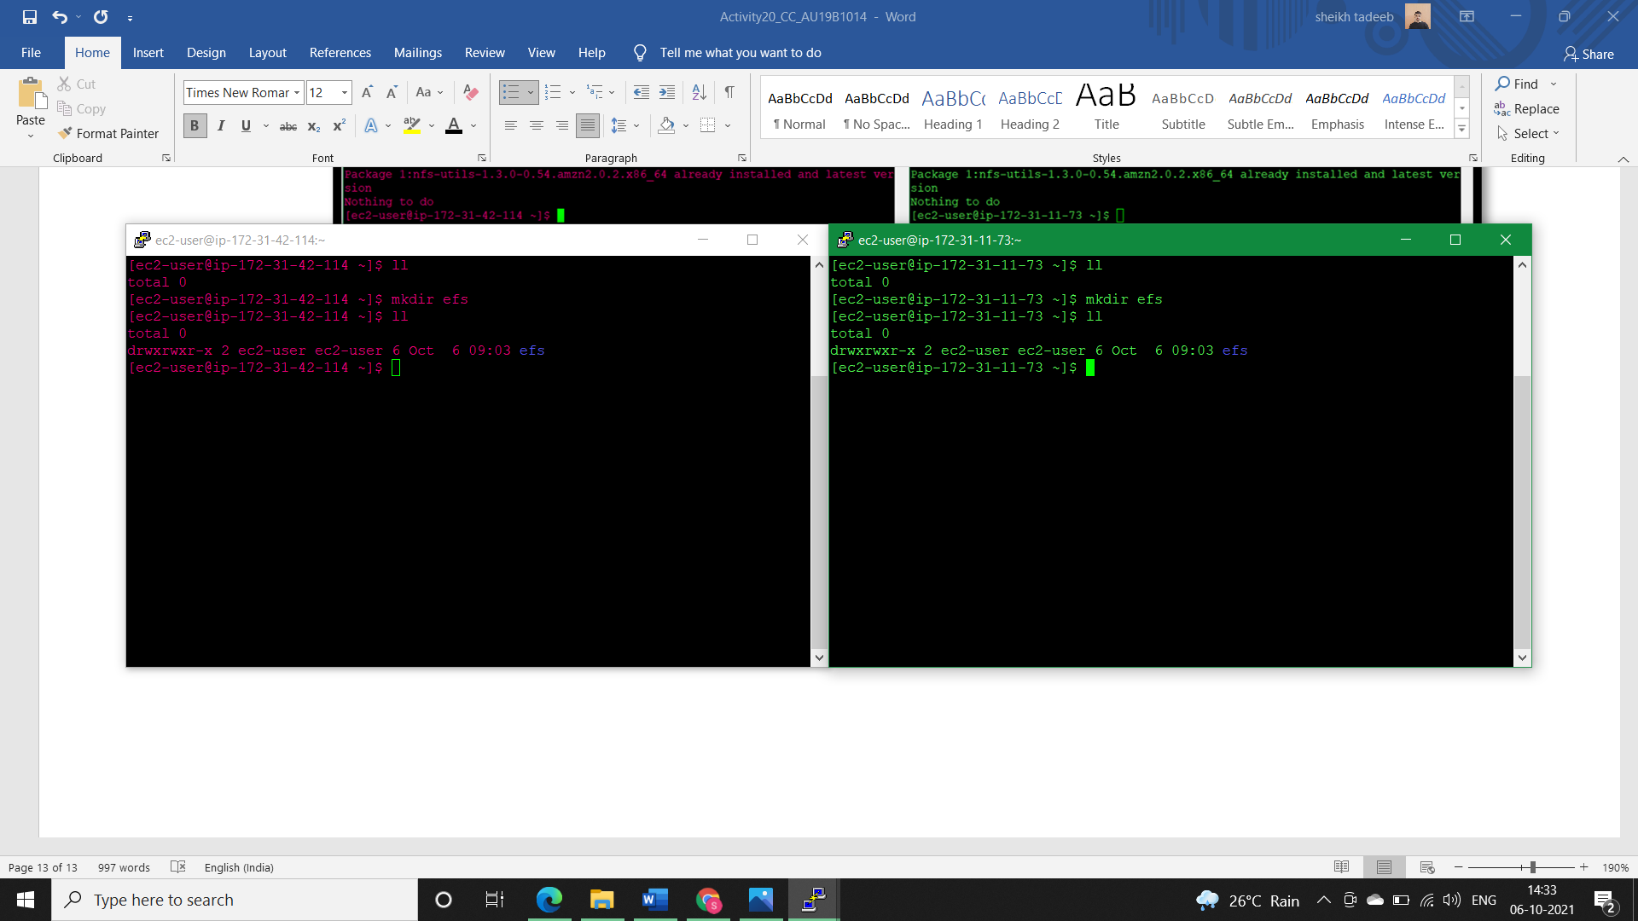

* **Step12)**
* Brief:

Now their exist two ways to mount our *efs* via DNS, so we will do with both ways. IN machine 1, I will do using *NFS client command* and in machine 2, I will do with EFS mount helper.

* **Step12.1)** Copy *NFS client command* and paste it in the putty machine-1 console, if no error comes that means our mount is done successfully and we can check it using the command *df -h*

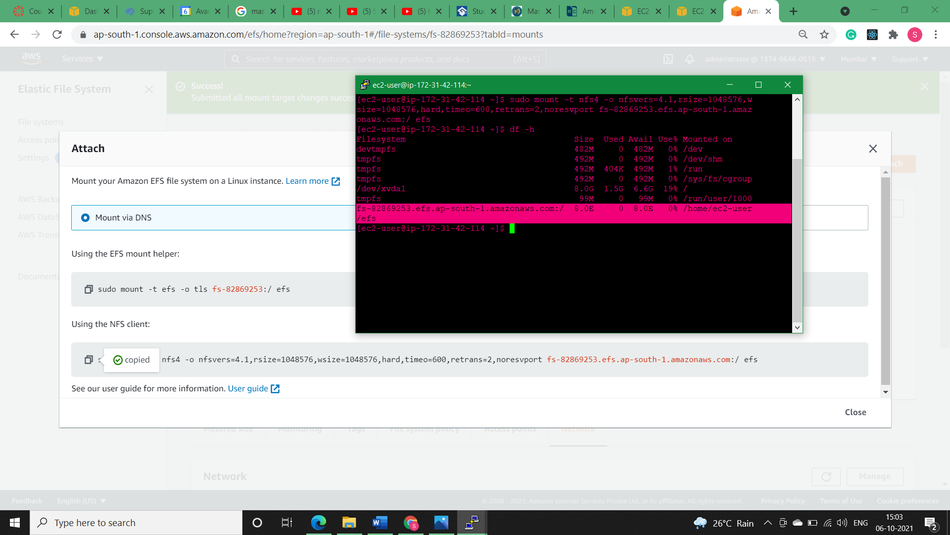

* **Step12.2)** Go to Machine-2 and Mount EFS using a *EFS Mount Helper*. To use EFS Mount Helper we need to install another helper utility with the command:

*sudo yum install amazon-efs-utils -y*

After this copy Mount helper command and paste it in putty console of Machine-2. If no error comes means our EFS is mounted properly and we can check mount points using the command:

*df- h*

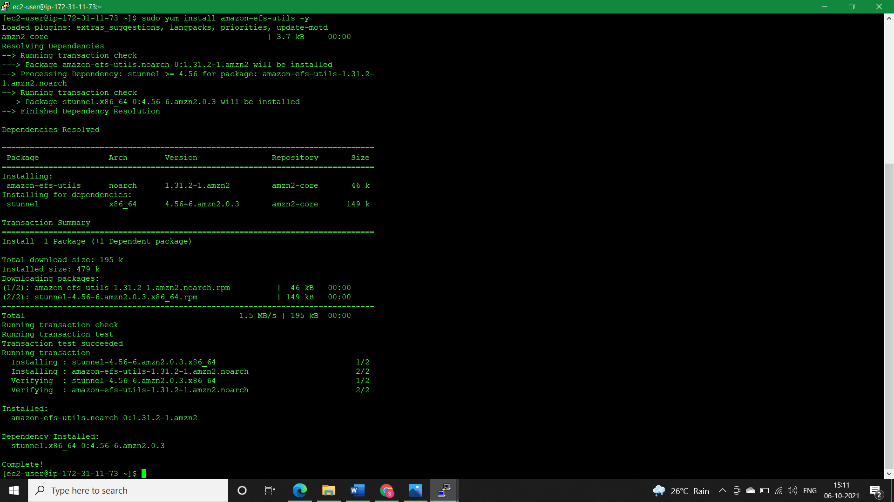

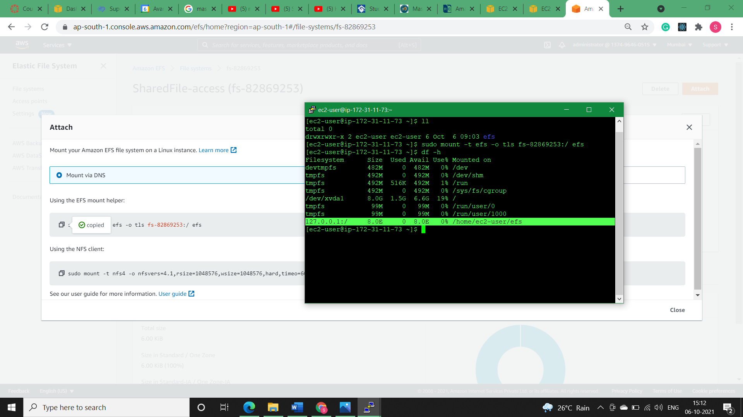

* **Step13)** We need to change the ownership of efs folder in both the ec2 machines so that our ec2-user could access it. 1st exit the efs folder using *cd which* will take us to root directory and then use command:

*sudo chown ec2-user efs/*

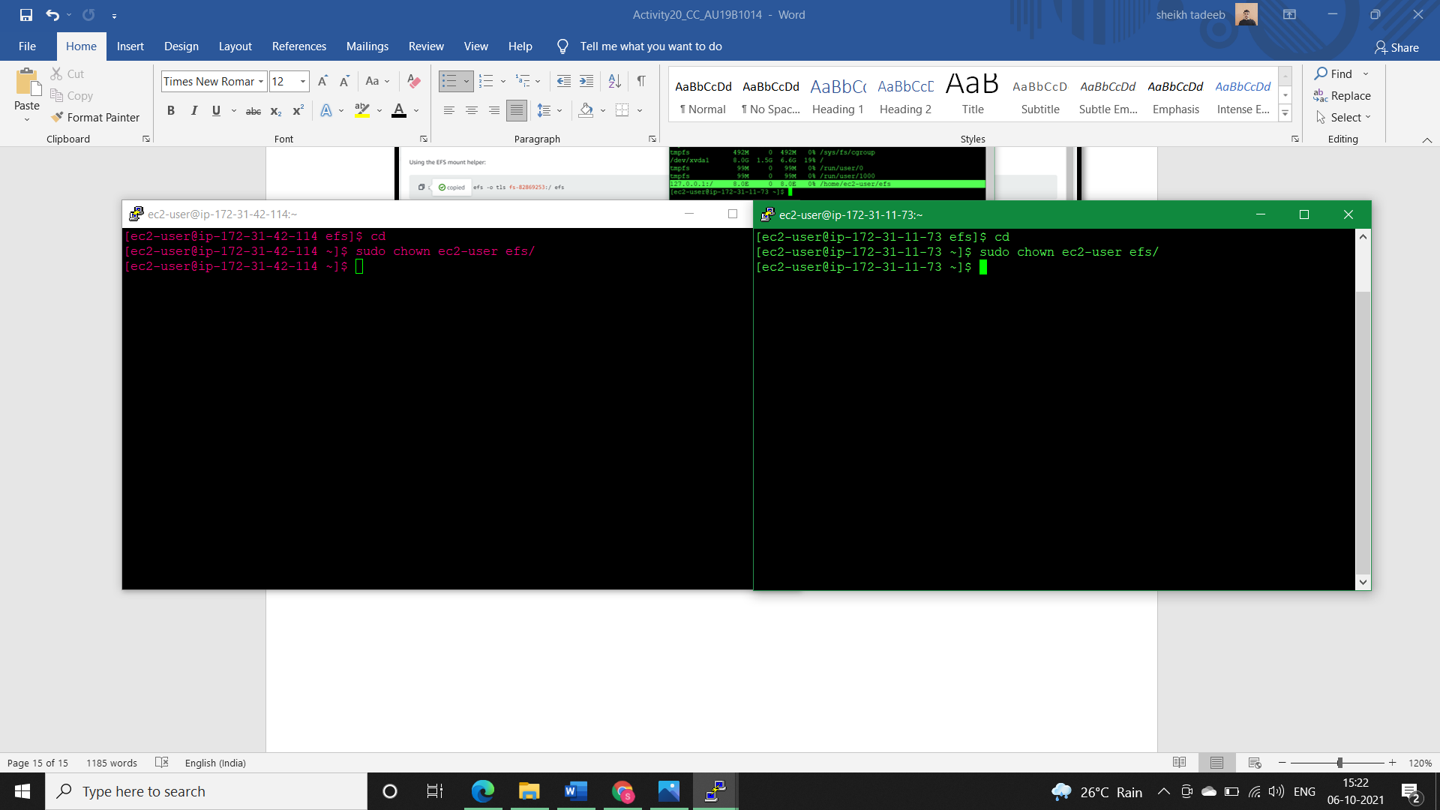



* **Step14)**
* **Brief:**

Now anything we create in EFS folder using one machine could easily be accessed by another machine as efs is a shared folder between them.

* **Step14.1)** Now we’ll check whether our efs folder is shared between the two machines in different AZ’s or not. For this we’ll enter in the efs folder through machine-2 and create text file and then we will check whether Machine-1 have access to this text file created by machine or not. If accessible, then we’ll make some updates in the same text file using machine-2 and reconfirm the changes from machine-1.
* **Machine-2:**

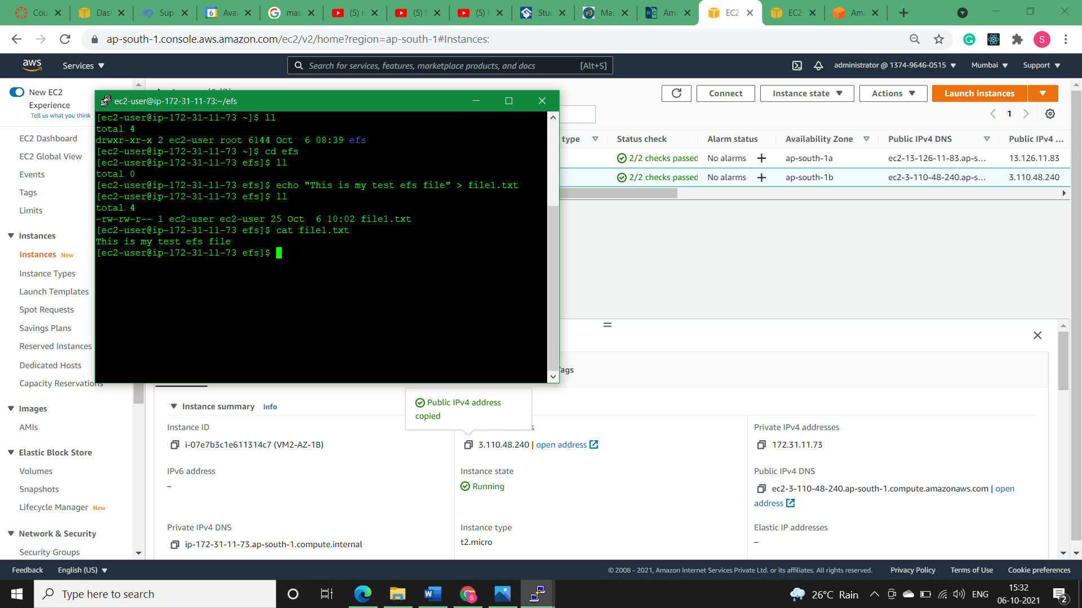

**Note:** In the Above Image we created a file1.txt from Machine-2 inside efs folder.

* **Machine-1:**

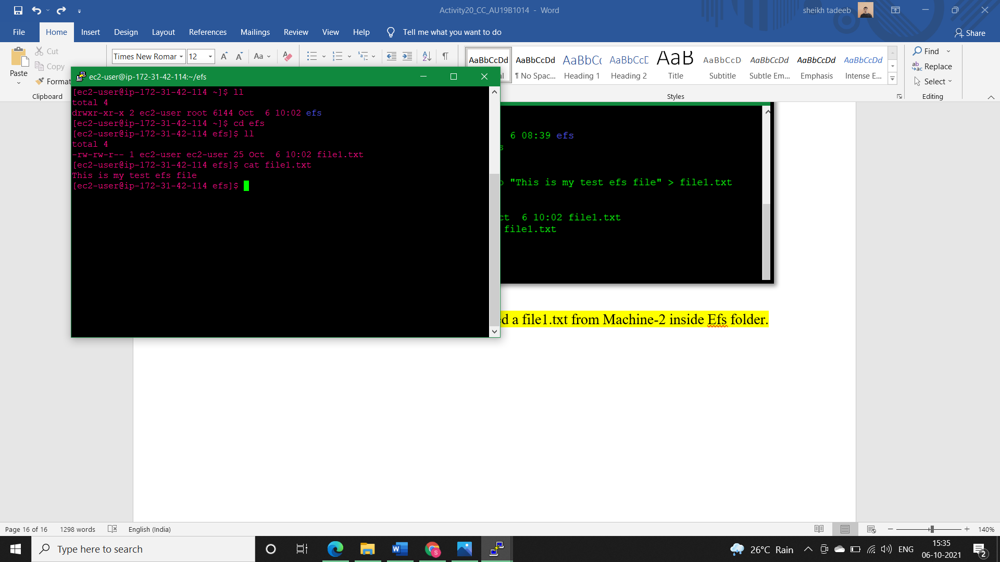

* **Note:** In the Above Image we found the same file1.txt which we created in Machine-2 inside efs folder.
* Now we’ll make some updates in the same text file using machine-2 and reconfirm the changes from machine-1.

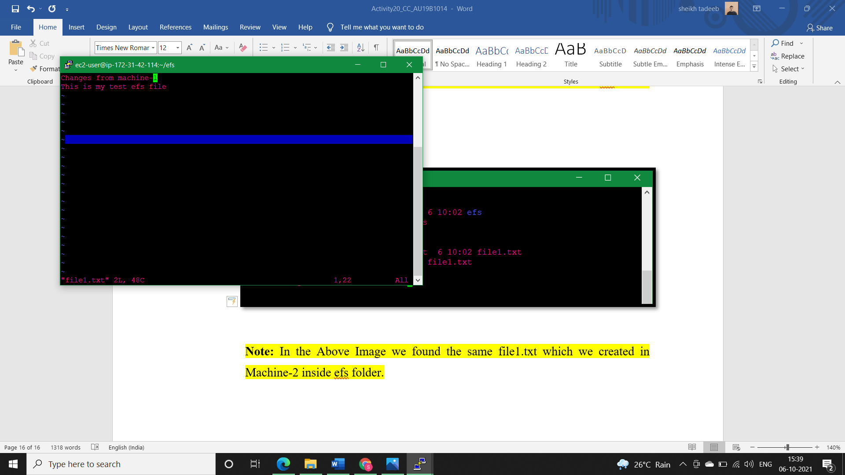

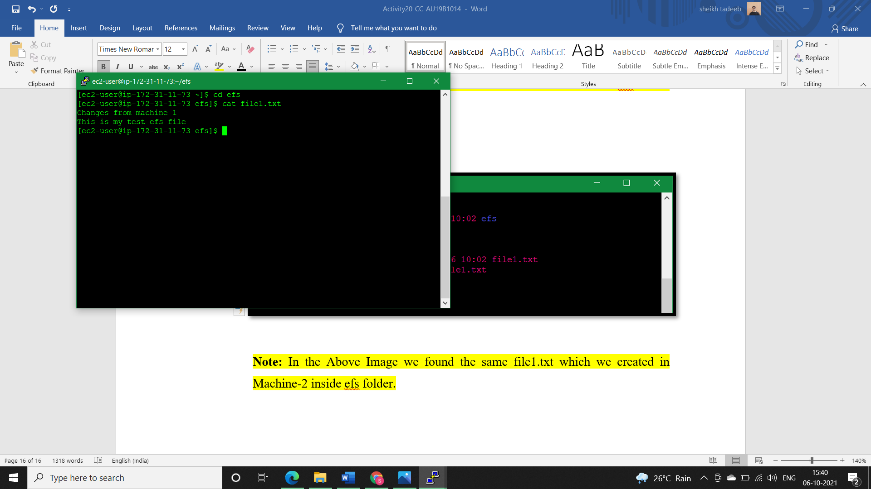

* **Conclusion:**

I checked whether our efs folder is shared between the two machines in different AZ’s or not. For this I enter in the efs folder through machine-2 and create text file and then I checked whether Machine-1 have access to this text file created by machine or not. The folder and file inside it were accessible, then I made some updates in the same text file using machine-2 and reconfirm the changes from machine-1. Hence, we can say that our EFS service of AWS is working properly.